In-Game Economy Analysis

(COMP3125 Individual Project)

Steven Lugo   
*Wentworth institute of Technology*

*Abstract*—Project for Comp3125, this document covers documentation and reasoning behind trends within an in-game economy. The game is Minecraft, within a Server Named “Hypixel,” and a particular game-mode called ‘Skyblock’

Thank you for reading this and providing feedback.

Keywords— Hypixel Skyblock Economy, In-Game Economy, Market Trends, Investment Strategies, Economic Sustainability, Virtual Markets, Player-Driven Trends

# Introduction

An engaging pastime of mine has been playing video games, particularly dedicating hundreds of hours to understanding the intricacies of in-game economies. One game that holds a special place in my heart is *Hypixel Skyblock*, a game mode within the widely known *Minecraft*. This project focuses on the detailed in-game economy of *Hypixel Skyblock*. Like real-world markets, the prices of in-game items are influenced by a variety of factors. My objective is to draw meaningful conclusions and insights from this virtual economy, with potential applications to real-life economic principles. Currently, while there are some readily available datasets and information from community discussions or public websites [Sources to be filled][2][3], much of the decision-making within the game relies on intuition about what constitutes a worthwhile investment. Key factors affecting the economy include in-game events, the influence of prominent players and content creators, and the requirements of newly introduced content. Additionally, I plan to observe player-driven trends more closely to identify key moments or areas of both market activity and in-game progress. These insights are the result of extensive research and personal experimentation, including tracking item trends and testing investment strategies. By considering these elements, I aim to provide a comprehensive analysis of the economy's status and offer recommendations for promoting its sustainability and future growth.

# Datasets

## Source of dataset

The datasets were collected by me using the provided Hypixel API. I had automatically set up polling around every 2 hours. Each request returned Json which had specific information extracted (Meaning some data would be lost). There is further information inside the ‘API’ folder within the project. As for the credibility of the information, I am drawing conclusions based on the information directly reported from Hypixel, the server host.

## Character of the datasets

The dataset at the time of this report was around ~4100 elements. In the future, collection of more data would be better for analysis, as certain features felt like they were missed, such as the rest of the mayors, and how much the recent update would impact the data. The form of the data is as follows:

|  |  |  |  |  |  |
| --- | --- | --- | --- | --- | --- |
| Timestamp | Player count | Product ID | Total Amount | Average Price Per Unit | Mayor |

With timestamp being the time the data was recorded in Epoch time (MS); Player count being from the specific game mode; Product ID being the name of the item; Total amount being the sum of every listing; Average price being Total amount / sum of price of every listing; Mayor being the elected mayor (in game event) at the time. Later, there will be additional features created that coincide with analysis.

# Methodology

This analysis examines the impact of specific in-game events, primarily those related to mayors, on the overall economy and item-specific pricing trends. To accurately assess price changes, the data was normalized using Z-scores. The analysis includes player count data, along with feature-engineered variables such as lag hours, supply, change, and volatility. These additional metrics provide deeper insights into price fluctuations, enabling more informed decision-making for potential investments.

The models implemented include linear regression, using np.polyfit, and decision trees, using XGBoost. The focus is on detailed factor-specific analysis rather than a generalized overview, aiding players in identifying longer-term investment opportunities.

To analyze the model's performance, MSE or mean squared error was used, which utilizes a square relationship between the difference of the mean and the current value, punishing larger deviations.

## Figure 1

*Mayor and Average Z-Score Deviation*

This figure provides a general overview of economic trends under specific mayors. Larger / wider peaks indicate larger amounts of the specific Z-score pricing. While the graph offers a broad perspective, a more in-depth analysis of individual mayors is necessary to uncover actionable insights.

Z-score is calculated as follows: (Value – mean) / Std Dev.

## Figure 2

*Mayor Item Z-Score Deviation*

Different mayors influence specific gameplay mechanics, incentivizing distinct money-making strategies and impacting item pricing accordingly. This granular analysis highlights item-specific trends and potential investment opportunities tied to mayoral effects.

## Figure 3

Player Count Vs. Select Items

The foundational principle of any economy, "supply and demand," predicts fluctuations in item supply based on player activity throughout the day. This figure models these trends over a 24-hour cycle, showing a linear relationship between player count and item supply fluctuations.

## Figure 4

Tree Modeling of Predictors to Z-Score Pricing

Tree-based models, particularly boosted trees, excel in comparing categorical variables and identifying nuanced relationships. While linear regression is a simpler alternative, tree models provide more granular insights. The most influential predictor identified was player count, which strongly correlates with Z-score price variations.

## Figure 5

# Feature-Engineered Tree Analysis

This model incorporates advanced predictors such as change in supply, volatility, lag hours, and day-specific trends. While subsampling techniques mitigate overfitting risks, the small dataset and identifying features (e.g., "change in amount") may reduce this model's predictive robustness.

Process: For lag times, the model was shifted the according hours, and for negative results, the Modulo operator was applied.

Day would be provided via Pandas functions

Lag amount shifted the dataset 1 pull request (24 notches) backwards

Change in supply = Total amount – Lag amount, when there was no previous amount, it would be filled with its value when data collection first started

Volatility was created using CV and the change ratio, or Total amount / Lag amount. The CV or coefficient of variation allowed estimation of typical behavior, allowing comparison to yield potential for variability. Thresholds were introduced at greater than a 50% decrease and the Change in supply compared to this:

## Figure 6

### Player Count vs. Pricing Trends (Daily): This figure examines daily trends, showing how weekends, with higher player activity due to reduced work and school obligations, influence supply and demand dynamics. The resulting price changes align with expected activity patterns.

### Item Volatility vs. Player Count (Daily): This analysis explores the relationship between player count and item volatility, emphasizing that reduced player activity often corresponds with higher volatility. Such periods likely represent peak price fluctuations.

## Figure 7

# Individual Item Trees

Given the unique behavior of items under different mayors and periods, individual item analyses are crucial. By isolating specific predictors for each item, this approach identifies the best investment opportunities. However, the dataset size limits accuracy, with only ~164 data points per item from the total dataset of ~4100 entries, increasing overfitting risks.

## Figure 8

Update Impact on Lava Orb and Other Items

This figure examines the effects of game updates on specific items, such as the Lava Orb. Updates that increase supply, as seen here, typically result in price drops. Conversely, items less directly affected tend to maintain or slightly decrease in price.

# Results

## Figure 1

The results of this model are mostly inconclusive. The trends are too general to obtain meaningful insight.

## Figure 2

# See notebook for detailed Observations

*Scorpius:* He is a special mayor, only appearing once every 8 game years or ~40 real life days. He affected Purple Jerry Boxes, Booster Cookies, Lava Water Orbs, and Soul flow. Lava Water Orbs are inconclusive, except for a drying supply, however the others indicate increasing player engagement, selling investments *(Jerry boxes)* and buying combat related items *(Booster Cookies / Soul flow)*

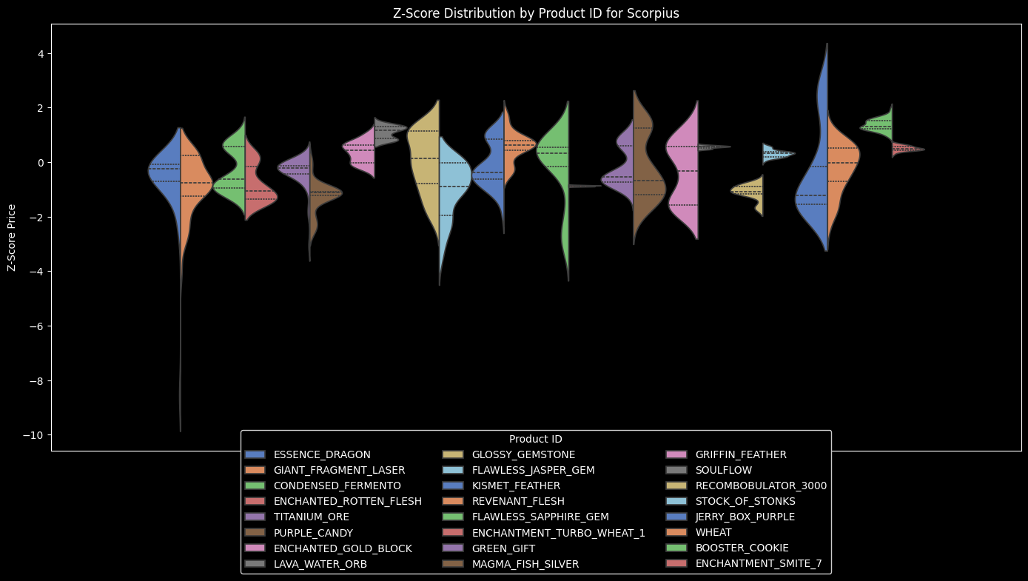

*Finnegan:* Primarily focusing on farming, he incentivizes players to farm, directly affecting wheat and Fermento supply. Additional impacts include Gifts and Jerry boxes, positively likely due to his buff experience. Recombobulators as a general item were effective, due to players needing them to improve their farming sets, both literally and metaphorically. Additionally, Jasper was affected, either due to the next mayor (Combat is special) or conversion factors between Jasper’s state and farming.

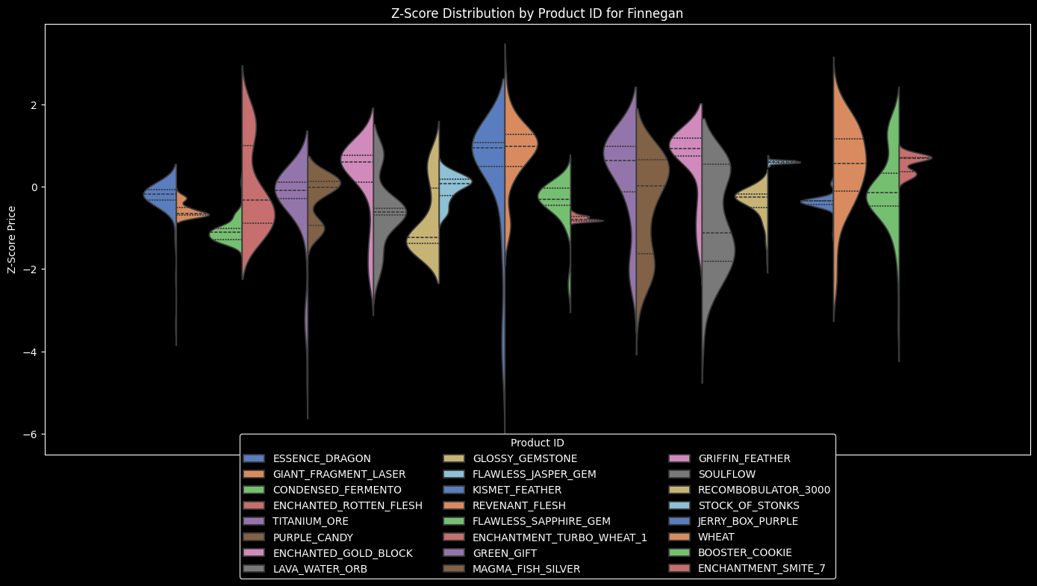

*Aatrox:* Aatrox specializes in slayers, the chosen items relating to him are Smite 7, Revenant flesh, and Enchanted Rotten Flesh. Smite 7 saw increases just before he was elected (due to it being used to hasten participation in specific slayers). While the flesh’s both saw increases just before the event, revenant would go down and rotten would go down as Aatrox remained in office.

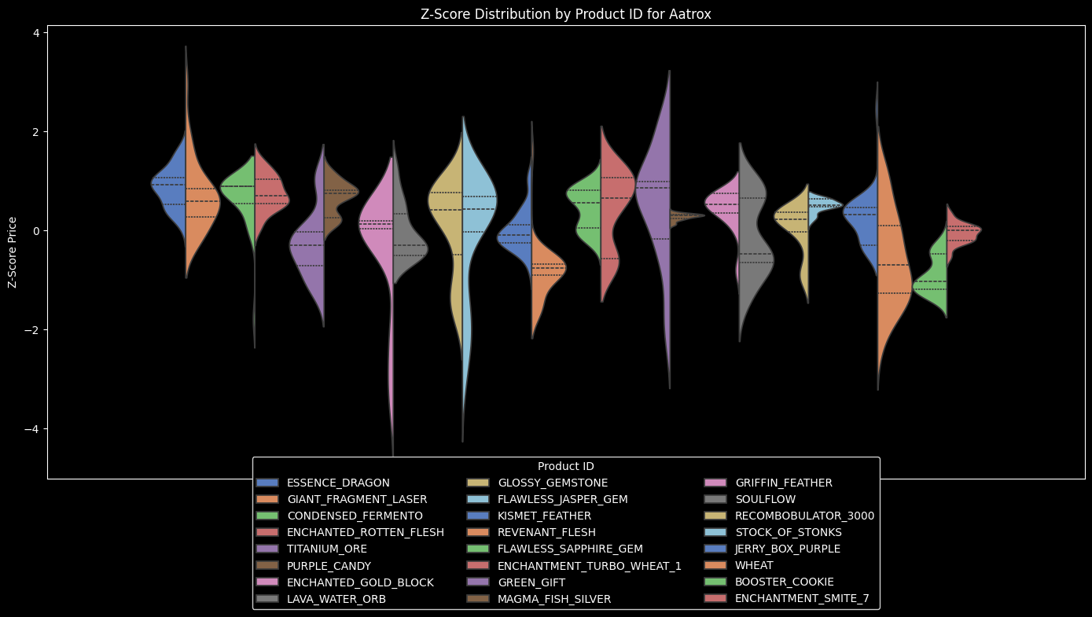

*Diaz:* A recent update introduced a purpose to a previously useless item; Stock of Stonks. Before this, the price increased, then deviated lower than the mean drastically. Kismet and Recombobulators saw large increases, and Lava water orbs decreased drastically, not due to the mayor, but a recent update.

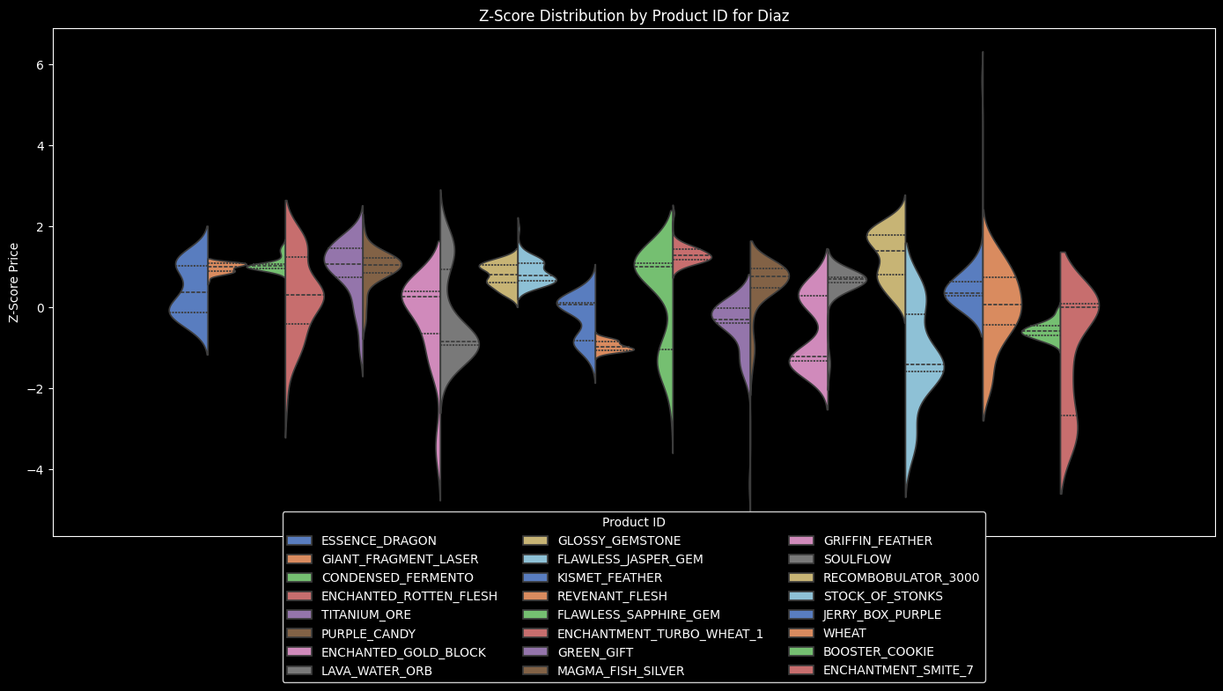

*Missing:* Due to a lack of time (To achieve every major would require a year's worth of preparation), this data misses' observations for Paul, Diana, Jerry, Derpy, Cole, Foxy, and Marina. Paul affects dungeon related items such as the Kismet Feather and Recombobulator. Marina focuses on fishing, specifically buffing and increasing fishing related supply. Cole focuses on mining, and impacts the gemstones mentioned in the dataset. Derpy is unknown, due to their broad effect, and limited sample size. Diana focuses on Griffin feathers and gold in their event.

## Figure 3

Certain items can be affected by the daily changes in player count. Specific Items include Kismet, Dragon essence, Jasper gemstones, Booster Cookies. Booster cookies show an interesting increase throughout the day entirely (Less people buy at night?)

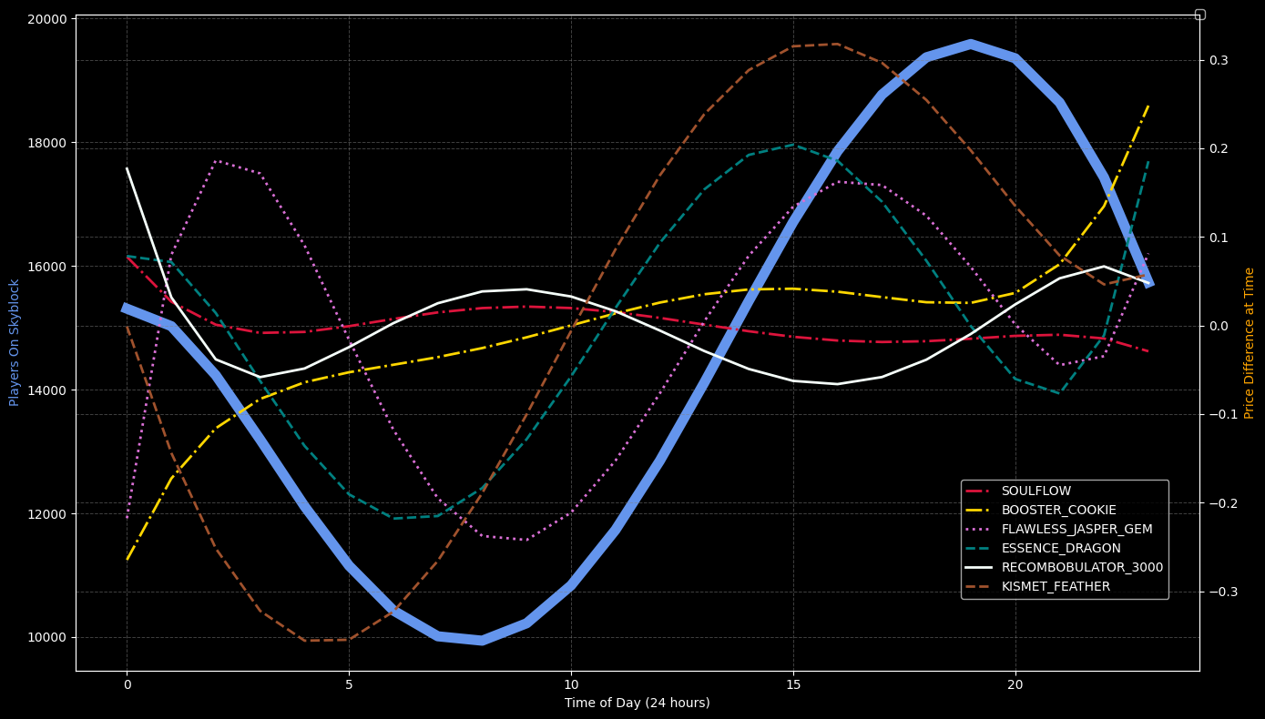

## Figure 4

Player count of the predictors has the largest impact on predictions, and the generated tree has a 0.9653667370000458 MSE.

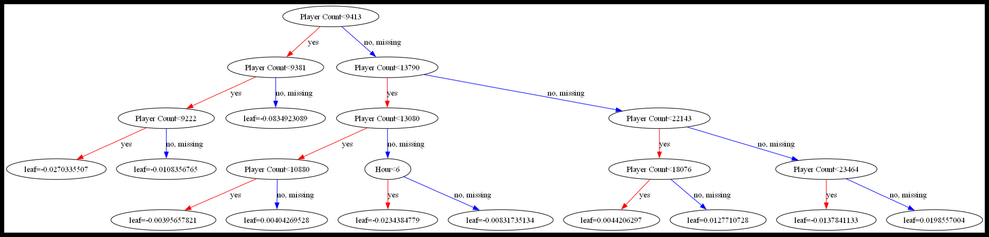

## Figure 5

Adding additional features allowed MSE to reduce by ~.10 to 0.826507844915336 MSE. The new greatest predictors are Lag_amount, Change_in_Supply, and Change ratio.

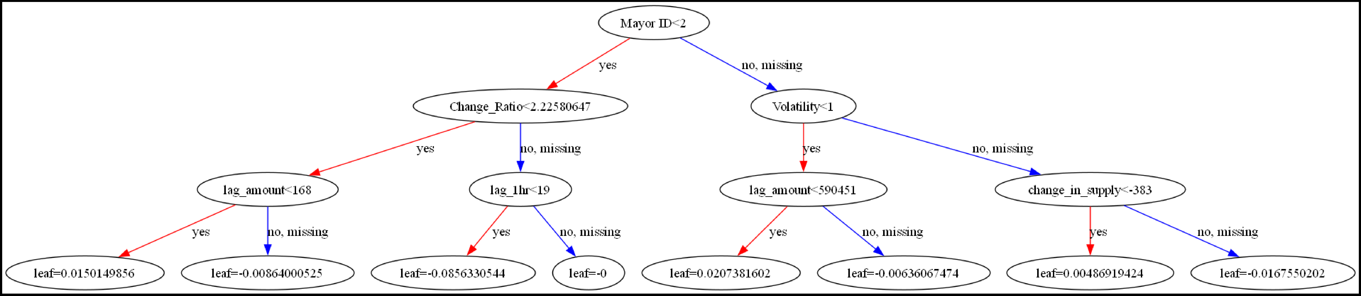

## Figure 6

### Weekends have higher players, and thus cause both an increase in supply and demand. As the weekdays progress, demand is greater than supply as prices begin to trend upwards, and back down for the weekend.

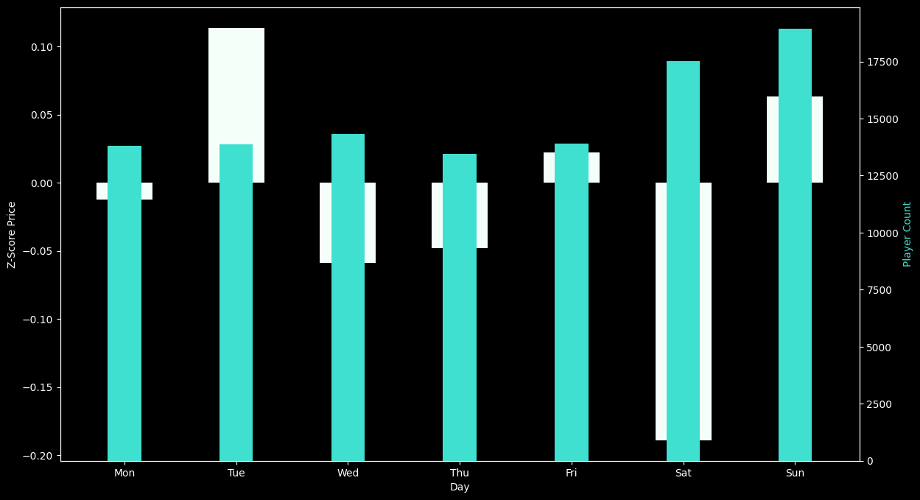

### Similarly, backing this up is the fact that volatility increases during the weekdays, and remains lower on weekends.

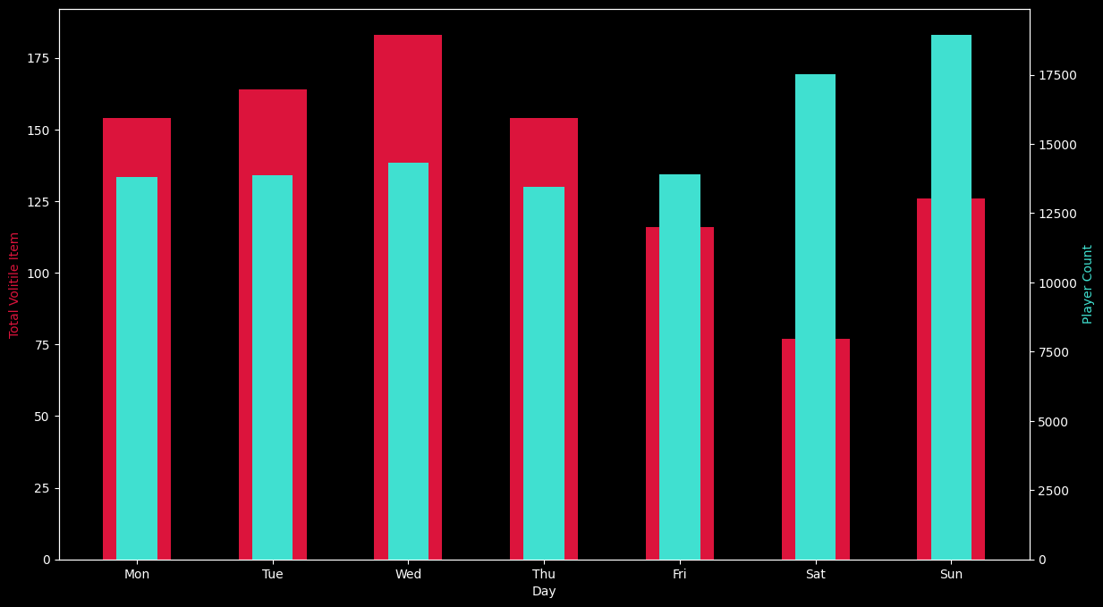

## Figure 7

1. Individual Product Performance

|  |  |
| --- | --- |
| Item Trees and Their MSE | |
| Item Name | MSE |
| ESSENCE_DRAGON | 0.5238336898718412 |
| GIANT_FRAGMENT_LASER  CONDENSED_FERMENTO | 0.3216968679478734  0.11155580360387045 |
| ENCHANTED_ROTTEN_FLESH | 0.2845227484119494 |
| TITANIUM_ORE | 0.2225126930181308 |
| PURPLE_CANDY | 0.12141784164251956 |
| ENCHANTED_GOLD_BLOCK | 0.5301067188572771 |
| LAVA_WATER_ORB | 0.29412136502290603 |
| GLOSSY_GEMSTONE | 0.6082984849471139 |
| FLAWLESS_JASPER_GEM | 0.6667626383054184 |
| KISMET_FEATHER | 0.6805002716201525 |
| REVENANT_FLESH | 0.17037478679704468 |
| FLAWLESS_SAPPHIRE_GEM | 0.3556092731790648 |
| ENCHANTMENT_TURBO_WHEAT_1 | 0.019599228861967695 |
| GREEN_GIFT | 0.3222976058127889 |
| MAGMA_FISH_SILVER | 0.571431968231439 |
| GRIFFIN_FEATHER | 0.24268819769042327 |
| SOULFLOW | 0.24756105314729454 |
| RECOMBOBULATOR_3000 | 0.057315847050694035 |
| STOCK_OF_STONKS | 0.4816099957703732 |
| JERRY_BOX_PURPLE | 0.6640561630836466 |
| WHEAT | 0.8007782970928343 |
| BOOSTER_COOKIE | 0.1323926168614903 |
| ENCHANTMENT_SMITE_7 | 0.13578178929304735 |

1. This may still be overfit due to sample size, explained previously

The items who take advantage of these predictors most are: Booster Cookies, Smite 7, Recombobulators, Turbo Wheat, Purple Candy, Condensed Fermento, and titanium ore with a lower than .2 MSE

## Figure 8

The update has indeed influenced the item, the materials decreased in scarcity resulting in a larger supply, and unfortunately a lower demand. Marina may surge price as this becomes more affordable for playerbase.

# Discussion

With everything, more data can prove to assist me. Figure 2 does a respectable job of observing trends; however, it covers a single instance of that mayor. In general, the data lacks analysis of other majors.

Figure 1 is undoubtedly too general.

Figure 4 has weaknesses that the latter figures ramify (to an extent)

Figure 5 teeters on the line of overfitting, as the patterns from Lag amount and change in amount are specific and almost work as hashes, especially in my small data set.

Figure 6 could use some clarification and would benefit from more data. Additionally, the major update was on a Tuesday, potentially skewing the data (Although at least for one item it decreases). Viewing the data in more detail may offer better insight.

Figure 7 suffers from identification due to specific near identifiers being used as predictors. Additional data may provide greater insight into trends.

Figure 8 is cluttered and does not clearly explain the trends of the rest of the data.

Example: xxx

# Conclusion

##### While analyzing an in game economy may not directly translate into the real world, it provides insight into how the world works. Furthermore, the plotting and API skills from working on such a project are surprising.

In terms of applicable, and more likely than not (Cannot say guaranteed) Investing during the weekend is beneficial, and focusing on mayor-related items can still yield great profits. There is potential for further growth of this data set. While the individual prediction models may not offer extensively accurate predictions, they do offer insight still, as effects come in many forms, both positive and negative. As for the state of Skyblock, the player count appears dwindling, however, the recent update has sparked some hope. The overall economy is fluctuating healthily, with the coin sinks counteracting inflation, and the prospect of a new update, investments may end up extremely worthwhile.

##### Acknowledgment *(Heading 5)*

##### References

[1] McKinney, W., "Data Structures for Statistical Computing in Python," in *Proceedings of the 9th Python in Science Conference*, 2010, pp. 51–56.

[2] Harris, C. R., Millman, K. J., van der Walt, S. J., Gommers, R., Virtanen, P., Cournapeau, D., ... & Oliphant, T. E., "Array programming with NumPy," *Nature*, vol. 585, no. 7825, pp. 357–362, 2020.

[3] Pdregosa, F., Varoquaux, G., Gramfort, A., Michel, V., Thirion, B., Grisel, O., ... & Duchesnay, É., "Scikit-learn: Machine Learning in Python," *Journal of Machine Learning Research*, vol. 12, pp. 2825–2830, 2011.

[4] Chen, T., & Guestrin, C., "XGBoost: A Scalable Tree Boosting System," in *Proceedings of the 22nd ACM SIGKDD International Conference on Knowledge Discovery and Data Mining (KDD)*, 2016, pp. 785–794.

[5] Hypixel Inc., "Hypixel Public API Documentation," [Online]. Available: https://api.hypixel.net. [Accessed: Dec. 9, 2024].

[6] Hypixel Inc., "Hypixel Skyblock," [Online]. Available: https://hypixel.net/skyblock. [Accessed: Dec. 9, 2024].